Making It OK To Complain
Mental Health Complaints Commissioner
Annual Report 2021/22
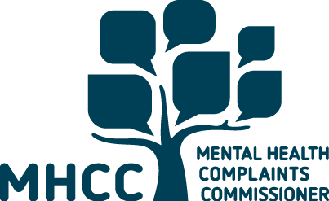

We acknowledge the First Nations People of Victoria as the Traditional Owners/Custodians of the land on which we conduct our business. We recognise their continuing connection to land, water and community and that sovereignty was never ceded. We pay our respect to Elders past, present and the emerging leaders of the future.
This report can be downloaded from the Mental Health Complaints Commissioner (MHCC) website at www.mhcc.vic.gov.au/annual-reports
This document is available in PDF and RTF formats on our website.
To receive a hard copy version of this publication please email: info@mhcc.vic.gov.au or call 1800 246 054.
Address: Level 26, 570 Bourke Street Naarm / Melbourne, Victoria 3000
Phone: 1800 246 054 (free call from landlines)
Complaints: help@mhcc.vic.gov.au
General enquiries: info@mhcc.vic.gov.au
Website: mhcc.vic.gov.au
Twitter: twitter.com/MentalHealthCC
Facebook: facebook.com/mentalhealthcomplaintscommissioner
Instagram: instagram.com/mhcc_vic
LinkedIn linkedin.com/company/mental-health-complaints-commissioner
ISSN 2209-1548 - Print
ISSN 2209-1556 - Online (pdf/word)
Authorised and published by the Victorian Government
© State of Victoria, Australia (Mental Health Complaints Commissioner), August 2022
With the exception of images, photographs or branding, this work is licensed under a Creative Commons Attribution 4.0 licence.
The terms and conditions of this licence, including disclaimer of warranties and limitation of liability are available at Creative Commons Attribution 4.0 International.
You are free to re-use the work under this licence, on the condition that you credit the State of Victoria, Australia (Mental Health Complaints Commissioner) as the author and/or owner of the work, indicate if changes have been made to the work and comply with the other licence terms.

Letter to the Minister
1 September 2022
The Hon Gabrielle Williams, MP
Minister for Mental Health
Level 22, 50 Lonsdale Street
Melbourne VIC 3000
Dear Minister,
I am pleased to provide you with the Mental Health Complaints Commissioner Annual Report for the financial year 2021/22.
As required under section 268 of the Victorian Mental Health Act 2014 (the Act), the report describes our activities for the year including the number of complaints made to the Commissioner, the outcomes of these complaints and our education activities.
I trust this Annual Report will help to inform the Parliament, consumers, families, carers, mental health services and the wider Victorian community about our key safeguarding, oversight and service improvement roles under the Act.
Yours sincerely
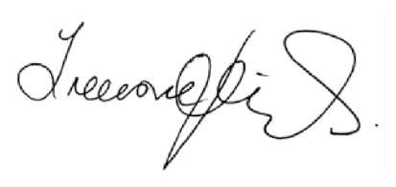
Treasure Jennings
Mental Health Complaints Commissioner
570 Bourke Street
Naarm / Melbourne Vic 3000
www.mhcc.vic.gov.au

Terminology used in this report

The Act
The Mental Health Act 2014 (Vic).

The Department
The Department of Health.

The Mental Health and Wellbeing Act (MHW Act)
The Royal Commission into Victoria’s Mental Health System recommended the Victorian Government repeal the Mental Health Act 2014 (Vic) and enact a new Mental Health and Wellbeing Act. The Victorian Government introduced the new Mental Health and Wellbeing Bill to the Victorian Parliament in June 2022.

The Mental Health and Wellbeing Commission (MHW Commission)
The Victorian Government is establishing a new MHW Commission. The new Commission will hold government to account for the performance, quality and safety of Victoria’s mental health and wellbeing system.
The MHW Commission will be an independent statutory authority. The Commission will be established with full powers and responsibilities when the new Mental Health and Wellbeing Act commences. At that time, it is proposed that the current powers of the MHCC will fold into the new Commission.

Services
The MHCC deals with complaints about public mental health services in Victoria. These include:
- Designated mental health services, including hospital-based, community, residential, specialist and forensic services
- Publicly funded mental health community support services if they are not funded by the National Disability Insurance Scheme (NDIS).

Definition of enquiry
An enquiry is a request for information, advice or assistance. Enquiries to the MHCC can include requests for information about accessing services
or how to make a complaint.

Definition of complaint
A complaint is an expression of dissatisfaction about a service for which a response or resolution is explicitly or implicitly expected from the MHCC or is legally required (based on Australian Standard AS/NZS 10002:2018). Complaints can be made over the phone, through our webform, or by email or letter. Under the Act, to be formally accepted and reviewed, complaints need to be made or confirmed in writing by the complainant.

Definition of in-scope complaint
Complaints about people’s experiences in Victorian public mental health services that were within the jurisdiction of the MHCC are known as in-scope complaints.

Definition of the types of resolutions

Fully or substantially resolved
Complaints where issues were either fully or substantially resolved or an agreement was reached on the proposed actions to address the issues raised. Overall, these complaints achieve a positive outcome in terms of the person’s concerns.

Partially resolved
Complaints where one or more of multiple issues raised were resolved, or partially resolved. Partially resolved complaints include complaints where the service committed to improvement actions that we assessed as appropriate in the circumstances, but where the person was not fully satisfied with
the outcome.

Not resolved
We recognise that it is not always possible to resolve complaints made to our office. In some complaints there are barriers to achieving a positive outcome, such as services not being able to reach agreement on the outcomes sought by the person. Where appropriate, we provide advice and recommendations to the service or to the individual about other possible courses of action, including referring them to Victoria Legal Aid or community legal centres for legal advice.

Resolution not applicable/possible
To accurately show our work in resolving complaints about public mental health services, the MHCC excludes all matters assessed as ‘resolution not applicable/possible’ when reporting on complaint outcomes. These are complaints, for example:
- where we were unable to progress because we could not contact the person who made the complaint
- the consumer at the centre of the complaint did not consent to the complaint proceeding, and we assessed that there were no special circumstances for accepting the complaint without consent
- we were unable to take further steps without the complaint being confirmed in writing and accepted as a formal complaint
- the complaint was more appropriately dealt with by another body (for example, the Mental Health Tribunal or Australian Health Practitioner Regulation Agency).
We provide information and assistance to address any concerns raised by a person contacting our office, in line with our ‘no wrong door’ policy. If the complaint is out of scope, we will give the person advice, information, contacts and referrals
wherever possible.

Definition of the 4 As of complaints resolution
The ‘4 As’ of complaint resolution are the positive outcomes that can result from people’s complaints about Victorian public mental health services.
The 4 As are:

Acknowledgement
People want their concerns to be heard and acknowledged and the impact of their experience to be recognised and understood. Acknowledgement of their rights and what should have occurred in a situation can also be important.

Answers
People are usually looking for an explanation as to why something happened or did not happen, or why a certain decision was made. For answers to be meaningful, they need to be provided in a way that can be understood by the person, and that encourages the person to ask further questions if needed.

Action
People will generally be seeking action to address their individual issue or a change to be made to improve their experience and treatment. Many people also make a complaint because they do not want a recurrence of the issue for themselves or for others and because they want services to take actions to achieve this.

Apology
A meaningful apology usually involves acknowledgement, answers, and actions by a service and, where appropriate, can assist in a person’s recovery and help to restore their confidence in the service provider.

Contents

Letter to the Minister 3
Terminology used in this report 4
Forewords 9
Message from the Commissioner 9
Message from the Assistant Commissioner, Lived Experience and Engagement 11
Message from the Assistant Commissioner, Resolutions and Investigations (Acting) 13
Message from the Advisory Council Chair 14
Our year at a glance 15
About us 16
How we work 19
Our impact 19
What did 2021/22 teach us? 31
How we help 33
Complaint examples 33
How We Safeguard 41
Creating a positive complaints culture 41
Our new assisted referral process 45
Our work around the use of restrictive interventions 46
Our role in creating change 50
Our outreach 53
A promising future 56
Appendix 1: Our operations 57
Appendix 2: Our compliance and accountability 58

Forewords

Message from the Commissioner

I wish to acknowledge people with lived or living experience of mental health issues, their families and supporters for the courage they show in speaking up and raising complaints with my office.
This year represents both another period of significant challenges for Victoria’s mental health system, and the beginning of change and hope, as we welcome the announcements of significant investments in Victoria’s mental health system to support the recommendations of the Royal Commission. The impact of COVID-19 continues to have devastating effects on the community and mental health services, and I also acknowledge the compounding effect of increased demand, staff shortages and fatigue on services and staff.
This year the MHCC has provided extensive feedback to the Department on the development of the proposed MHW Act, particularly in relation to the provisions about the MHW Commission. Having reviewed the Bill, I especially welcome the focus on the elevation of carers rights and the vastly expanded role of people with lived experience in all aspects of the design and delivery of the mental health system, particularly the inclusion of two Commissioners with lived experience as a consumer and as a carer. Our strategic focus has continued to be shaping our processes and building our capabilities to support the ambitions of the proposed legislation and the new MHW Commission.
Complaints to the MHCC remind us just how important the lived experience inclusion will be if real system and culture changes are to be realised. As with previous years we heard that consumers wanted more voice and choice in their treatment. Arguably, giving consumers enough time to understand their treatment and express their concerns and preferences has been difficult this year with the stresses placed on services, but ultimately there is no alternative, and consumers rights to meaningfully engage in their treatment must be upheld. This year, as with last year, we have focused on facilitating these conversations between services and consumers and being the link in rebuilding trust and understanding when consumers feel they are not being heard.
A significant concern remains in the use restrictive interventions with 52 complaints containing issues about the use of mechanical or physical restraint or the use of seclusion. These complaints are more prevalent in the emergency department setting. Over the years the MHCC has made numerous recommendations relating to the use of these practices and, with these practices still widely in use, compliance with the Act and previous recommendations is of the utmost importance. While the use of restraint and seclusion and their inclusion in both the current and proposed legislation remains contentious, it nevertheless requires that when used, evidence must be demonstrated that all the required statutory safeguards have been applied. The MHCC has developed a new questionnaire for services to complete which streamlines our ability to confirm compliance or consider investigating where evidence is lacking or raises concerns.
Our aim is to raise standards and effect change. This change comes about through the courage of consumers, carers and families and the work of my incredible team. The resolutions and investigations teams at the MHCC balance the role of independence and the need for compassion with incredible skill. We have not been immune to the challenges of attracting and retaining staff during the pandemic, and at times team members have had to manage a large caseload.
I wish to acknowledge the patience, understanding and empathy shown by the MHCC staff to both consumers, carers, families and services, and of course to one another, during another busy year. I also wish to acknowledge the work of the MHCC Lived Experience team, which includes our communications and project functions, and of course our passionate Lived Experience Advisory Council. The MHCC is driven by lived experience and every day I learn something new from both the team and the Council.
Treasure Jennings
Commissioner

Message from the Assistant Commissioner, Lived Experience and Engagement

This year we have successfully developed and launched several projects aimed at directly impacting the care and treatment of consumers, carers and families within the public mental health system. Our focus for these projects was to improve the complaints system in practical ways and work with a range of people with lived experience through co-design to ensure we are driven by their unique perspectives and experiences.
During the year, we launched the Complaints Self-Assessment Tool for service providers (see page 27). This tool allows services to evaluate their capabilities and systems related to complaints processes within their individual service. It is an online tool that can be completed by anyone, at any level within the service. The tool covers several areas of work and individuals can answer the section that is most relevant to their work and service. The feedback so far indicates that the tool is very useful and has assisted many services to review their complaints processes and identify improvements.
We also launched the ‘It’s OK to Complain!’’ campaign this year which consists of a series of posters and postcards placed in and around in-patient units, as well as digital resources, which highlight the consumer’s right to speak-up to either the service or the MHCC if they have concerns (see page 26). The aim of the campaign is to address stigma and encourage consumers and staff to feel it’s OK to deal with a complaint at a local level in the first instance. We know that poor communication is a significant driver of complaints and encouraging consumers and carers to complain directly to the service can bring about quicker resolution. The campaign also reinforced that consumers and carers may contact the MHCC if they prefer.
We also developed and launched the Lived Experience Engagement Checklist which aims to embed better practice within services when engaging people with lived experience of mental health issues in a project or function (see page 27). Staff can answer a series of questions to better understand ways to improve the engagement and feelings of safety for lived experience staff and advisors.
To facilitate our goal to be more accessible the MHCC has begun development of an animation of MHCC’s complaints process. The animation will use plain English to explain how to make a complaint to the MHCC and what types of resolution can be achieved. We also intend to translate our information into other languages, so we can reach even more people across different cultural communities within Victoria.
The MHCC uses the Driven by Lived Experience Framework in all the work we do, the framework influences our engagement with consumers, carers and families to achieve the best possible outcomes in complaints processes. Moving forward, we will have Senior Advisers representing both consumers and carers/families in preparation for the expanded rights of carers and families within the proposed MHW Act.
Maggie Toko
Assistant Commissioner, Lived Experience and Engagement

Message from the Assistant Commissioner, Resolutions and Investigations (Acting)

This year we continued to witness the challenges faced by Victorians about their health and mental health, while trying to move forward on their journey of recovery and wellbeing. The MHCC team are proud of the continued support we provided to consumers, their families and carers, and of the support given to help services positively engage in handling complaints and identifying opportunities for better service provision. We have not stopped taking complaints throughout the pandemic, and our resolutions and investigation team worked tirelessly responding to enquiries, listening to concerns, facilitating resolutions and ensuring people’s rights are held at the centre of our practices. After a long time spent working remotely and unable to take live phone calls, we have now returned to receiving live calls and providing immediate access to callers who reach out to the MHCC.
We also developed a wide range of learning opportunities for our teams aimed at developing their skills in complaints resolution and trauma informed practices. We focused on how we can better include the lived experience lens and a continuous improvement approach to our work. Despite these challenges, and as part of improving our oversight capabilities, we have developed a new practice requiring services to provide feedback to the MHCC when complaints are referred to the service to resolve. We have also focused on developing new reporting capabilities and will continue to find opportunities to share more information with services and the public as these capabilities increase.
I have greatly enjoyed my time as Acting Assistant Commissioner and wish to thank my peers, team and staff in services for their support. It has been a fantastic opportunity to work with people who place human rights at the centre of their work.
Ghada Maher
Assistant Commissioner, Resolutions and Investigations (Acting)

Message from the Advisory Council Chair

During the year the Advisory Council were pleased to again play an active part in shaping and developing discussions and new initiatives from the MHCC. As a Council we are privileged to share our voices and experiences in a way that can truly help consumers, carers, services and indeed the system, now and in the years to come.
On behalf of the Council, I sincerely thank our previous Chair, Tom Wood who provided exceptional leadership to the group during his tenure and I am grateful for his ongoing position within the Council. I also pass on my thanks to the MHCC staff who consistently demonstrate their desire to genuinely include lived experience perspectives into their projects. In particular I recognise Senior Advisor Lived Experience and Engagement Emma Bohmer, for her endless support of the Advisory Council and her relentless passion to giving prominence to lived experience and voices in MHCC’s work.
I also extend my gratitude to my fellow colleagues on the Council: Susie Alvarez-Vasquez, Robyn Callaghan, Katrina Clarke, Julie Dempsey, Elvis Martin, Annette Mercuri, Oliver Ryan, Gloria Sleaby and Mary Tsiros. It is a pleasure to be a part of such a passionate team who so willingly and fearlessly share their lived experience perspectives. I find it incredibly humbling that you share my hope that together we can have a positive impact on the mental health system for all Victorians and I hope you share my pride in all that we have achieved this year.
Dean Duncan
Chair, Advisory Council

Our year at a glance

How many people contacted us?
This year the MHCC received:
2,345 new enquires and complaints
2,106 were complaints, 8% down from last year
1,588 of the complaints received were in-scope and progressed by the MHCC
1,027 complaints were received via telephone
561 were received in writing, including via our webform

Who contacted us?
72% of in-scope complaints were raised by consumers who received services themselves
25% by carers and family members
3% by others, including friends, advocates, lawyers, service staff or an unknown complainant

Services
91% of in-scope complaints received were about designated mental health services. 1% were about mental health community support services and 8% were unknown
17% of complaints were about regional public mental health services
73% of complaints about metropolitan public mental health services. Details of complaints by service are on page 13

About us
The MHCC is an independent specialist body established under the Act. Our Commissioner and staff safeguard people’s rights, resolve complaints and recommend service and system improvements.
Driven by lived experience, the MHCC works with consumers, families, carers, support people and mental health service staff to resolve people’s complaints. We do this in ways that support people’s recovery and wellbeing and improve the safety and quality of mental health services for all.
Our vision is a public mental health system that welcomes and learns from complaints, makes quality and safety improvements to protect the rights of consumers, families and carers, and upholds the principles of the Act in all aspects of service delivery.
A fundamental objective of the Act is to protect the rights and dignity of people accessing public mental health services and to place them at the centre of their treatment and care. The MHCC support this by working with people and services to resolve complaints in ways that:
- promote and safeguard consumers’ rights under the Act and its mental health principles, the Victorian Charter of Human Rights and Responsibilities Act 2006 and other relevant standards and guidelines
- are trauma-informed, meet peoples’ diverse individual needs and support recovery by ensuring people are heard, respected and feel confident that their views and preferences have been appropriately considered
- improve individual experiences and help people build the confidence, knowledge and relationships needed to raise concerns directly with the service
- listen to people’s concerns and draw on what they tell us to influence our work with services to improve the safety and quality of mental health services for all Victorians.

The MHCC’s functions
The MHCC has broad functions under s 228 of the Act, including to:
- accept, assess, manage and investigate complaints relating to public mental health services
- endeavour to resolve complaints in a timely manner using formal and informal dispute resolution (including conciliation), as appropriate
- issue compliance notices
- provide advice on any matter relating to a complaint
- make the procedure for making complaints in relation to services available and accessible, including publishing material about the
complaints procedure
- provide information, education and advice to services about their responsibilities in managing complaints
- assist consumers and people acting on behalf of, or who have a genuine interest in the wellbeing of, consumers to resolve complaints directly with the service, either before or after the Commissioner accepts the complaint
- assist services in improving policies and procedures for resolving complaints
- identify, analyse and review quality, safety and other issues arising from complaints and to provide information and make recommendations for improvements to services, the Chief Psychiatrist, the Secretary of the Department of Health, the Minister for Mental Health and other agencies as listed
- investigate and report on any matter relating to services at the request of the Minister.
Our complaints resolution, strategic projects, education, engagement and local complaints reporting activities all aim to support positive complaints cultures in mental health services, where people feel listened to and supported to raise their concerns, and where services respond effectively to complaints and make improvements where needed.

The MHCC Advisory Council
The MHCC’s Advisory Council ensures our work is driven by people with lived experience. Members include consumers, families, carers, support people and people who work in public mental health services. They are people of different ages, cultural backgrounds and gender and sexual identities. Each member is strongly committed to improving the public mental health system for all.
Council members use their expertise and experiences to give us strategic advice and collaborate on our projects and day to day work. They offer their unique insights into areas such as lived experience of mental health services and co-design and co-production. They also make recommendations for cultural and practice change within services and the MHCC.

How we work

Our impact
Every day we learn from the experiences people share with us, and we see complaints as an essential part of building a better system for the future.
Receiving complaints and achieving resolutions for complainants allows us to identify areas for improvements at an individual services level, as well as broader themes for improvement system-wide which we use when making contributions to projects or inquiries aimed at system improvement.

Complaints made to the MHCC
This year the MHCC received 2,345 new enquiries and complaints. This is the first time since 2014 that there has been a decrease from one year to the next. This may be a result of the MHCC’s continuous effort to promote a positive complaints culture at services and more complaints being made directly to services.
Of the 2,106 complaints received, 1,588 were in-scope and were progressed by the MHCC. In-scope complaints are those that are made about people’s experiences in Victorian public mental health services within the MHCC’s jurisdiction.
When the MHCC receives complaints that are out of scope (not within our jurisdiction because the complaint is not about Victorian public mental health services), where possible we continue to support people to contact the most appropriate body to help them with their concerns. This was the case for 518 complaints this year, where the complaints were commonly about general health services, private mental health practitioners, or mental health services in other jurisdictions.

Who made a complaint?
Figure 1: Who made complaints to the MHCC?
(Based on in-scope complaints)
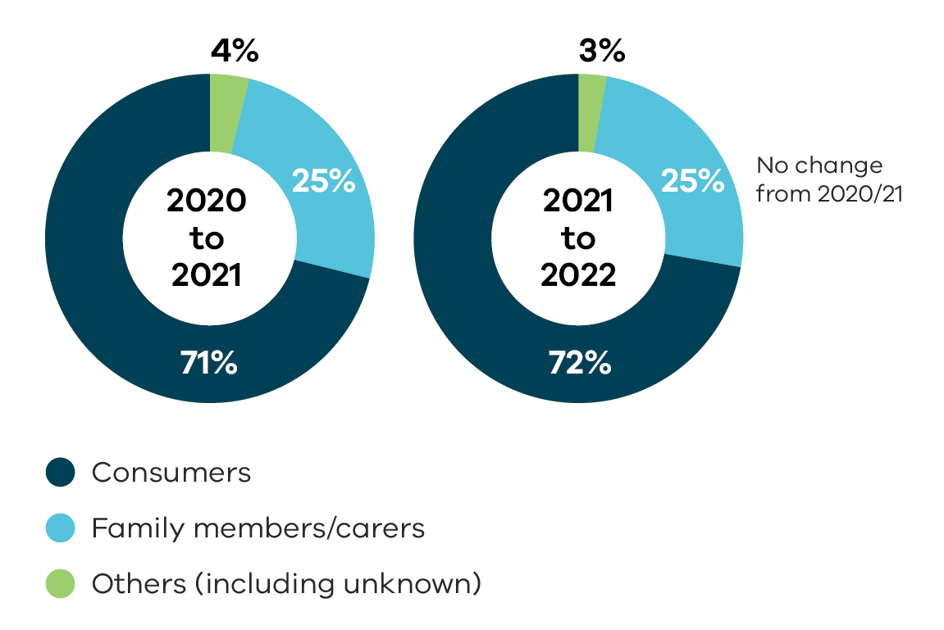
Data table for Figure 1:
Who made complaints | 2020 to 2021 | 2021 to 2022
Consumers | 71% | 72%
Family | 25% | 25%
Others (including unknown) | 4% | 3%
* The MHCC continued to operate for most of the reporting year on a call back system. In some instances we were unable to make contact with the caller to clarify their complaint.

Mental Health services
Of the 1,588 in-scope complaints received this year, 1,452 (91%) were about people’s experiences in designated mental health services (DMHS) including hospital-based, community, residential, specialist and forensic services. This was 3% lower than last year.
As in previous years, there were fewer complaints made about mental health community support services (MHCSS), when compared to complaints made about DMHS with only 12 (<1%) complaints received about these services.
For 124 (8%) of the in-scope complaints received by the MHCC we did not have sufficient information to identify if the service provider is a DMHS or a MHCSS. This is the case when a complaint may be in-scope but unlikely to progress because we were unable to contact the complainant for further information, because the complainant wished not to report where the issue had occurred, or because the complainant chose not to continue with the complaints process.
This year, we are reporting on the distribution of complaints about services across metropolitan and regional areas in Victoria. As expected, most complaints relate to metropolitan services.
Figure 2: Distribution of complaints about designated mental health services across metropolitan and regional areas in Victoria.
Metropolitan area | Distribution of complaints
Alfred Health | 113
Austin Health | 60
Eastern Health | 162
Forensicare | 68
Melbourne Health | 326
Mercy Public Hospitals incorporated | 108
Monash Health | 178
Peninsula Health | 60
Royal Childrens Hospital | 8
South West Health Care | 34
St Vincents Hospital | 54

Regional | Distribution of complaints
Albury Wodonga | 24
Ballarat Health Services (Grampians Health) | 49
Barwon Health | 42
Bendigo Health | 62
Goulburn Valley Health | 18
La Trobe Regional Hospital | 57
Mildura Base Hospital | 12
* This list refers to complaints made about DMHS only
* This list excludes a number of complaints where the service was not known.

Interpreting the data
Caution should be used when drawing conclusions from absolute numbers of complaints reported by services.
The number of complaints does not take into account the number of people who accessed each service and that larger services are expected to have a higher number of complaints. Further, high numbers of complaints reported by services may represent effective complaints reporting processes, a positive complaints culture and/or demonstrate high numbers of issues experienced by people who use the service.
Conversely, low numbers of complaints may indicate issues with the recording of complaints or the service’s approach to complaints, or a high level of satisfaction with the service.

What were complaints about?
Complaints raised with the MHCC often involve more than one issue. In this annual report, the number and percentage of complaints about each issue are recorded for all in-scope
complaints received.
The MHCC uses a three-level system to classify issues raised in complaints (details of this classification can be found on our website at:
https://www.mhcc.vic.gov.au/complaints-reporting-public-mental-health-services).
Each level has increased specificity about what the complaint is about (Figure 3).
- Level 1 issues capture the broad themes behind complaints
- Level 2 breaks these issues down into more specific groups
- Level 3 issues provide more detailed information about the complaint
Figure 4 outlines an example of complaint classification.

Figure 3: The MHCC’s three-level system to classify issues raised in complaints
Image transcription:
- Themes
- Specific groups
- Details about the complaint
End transcription
Figure 4: Complaint classification
Image transcription:
Level 1
Level 1 issues consists of:
- Treatment
- Communication
- Conduct and behaviour
- Medication
- Diagnosis
Level 2
Level 2 issues break down Level 1 issues into more specific categories.
For example, the Level 1 category Medication includes the following Level 2 issue:
- Medication error
Level 3
Level 3 issues further break down Level 2 issues.
For example, the Level 2 category Medication error includes the following Level 3 issue:
- Wrong medication or dose
End transcription

Figure 5 below shows the most frequently raised level 1 issues; and reports changes from the previous reporting year. More specific issues are also highlighted for the most frequent broader themes.
Treatment, communication, medication, conduct and behaviour, and diagnosis continued to be raised through complaints as recurring issues, consistent with previous years. This indicates the continued need for services to work on ways to support people make decisions and choices about their treatment and care, and to support staff to treat all consumers, families and carers with compassion and empathy.
Figure 5: Frequently raised level 1 issues
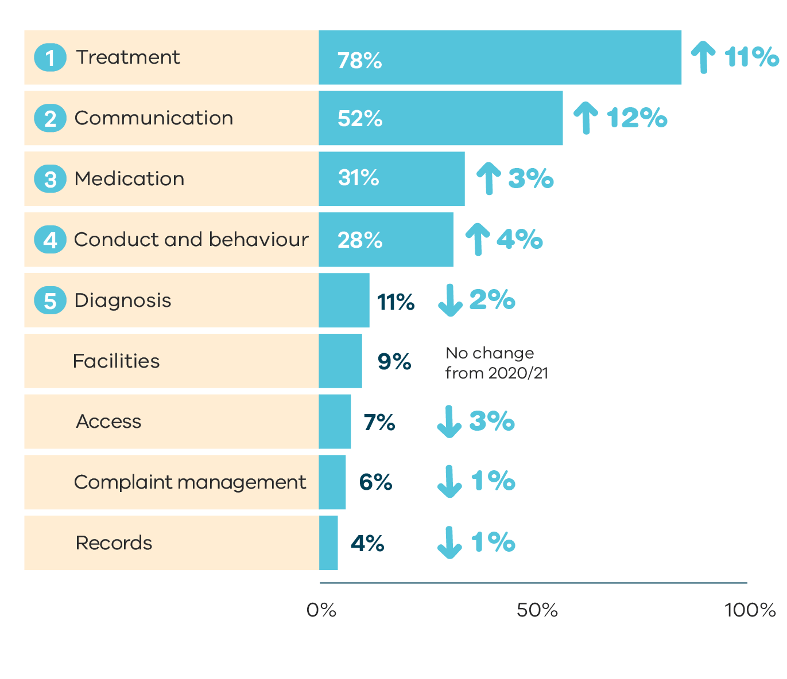
Data table for figure 5:
Issue | Percentage | Change from 2020/21
Treatment | 78% | Increased 11%
Communication | 52% | Increased 12%
Medication | 31% | Increased 3%
Conduct and behaviour | 28% | Increased 4%
Diagnosis | 11% | Decreased 2%
Facilities | 9% | No change from 2020/21
Access | 7% | Decreased 3%
Complaint management | 6% | Decreased 1%
Records | 4% | Decreased 1%
Figure 6: Most frequently raised level 2 issues for the top five level 1 issues
Image transcription:
- Treatment – Responsiveness of staff and suboptimal treatment
- Communication – Inadequate communication with consumer and inadequate communication with family/carer/other
- Medication – Disagreement with medication and over sedation or side effects
- Conduct and behaviour – Responsiveness of staff and rudeness/lack of empathy
- Diagnosis – Incorrect diagnosis and inadequate/inappropriate assessment
End transcription
The most commonly reported level 3 issues were themes of inadequate consideration of the person’s views and preferences when receiving compulsory treatment; lack of empathy or compassion; lack of communication with the family, carer, or nominated person; inadequate, incomplete or confusing information provided to the family member, carer or nominated person; and incorrect or disputed diagnosis.
Figures 7-11 show the most common level 3 issues that people made complaints about this year and reports changes from the previous year.
Figure 7: Frequently raised level 3 treatment issues
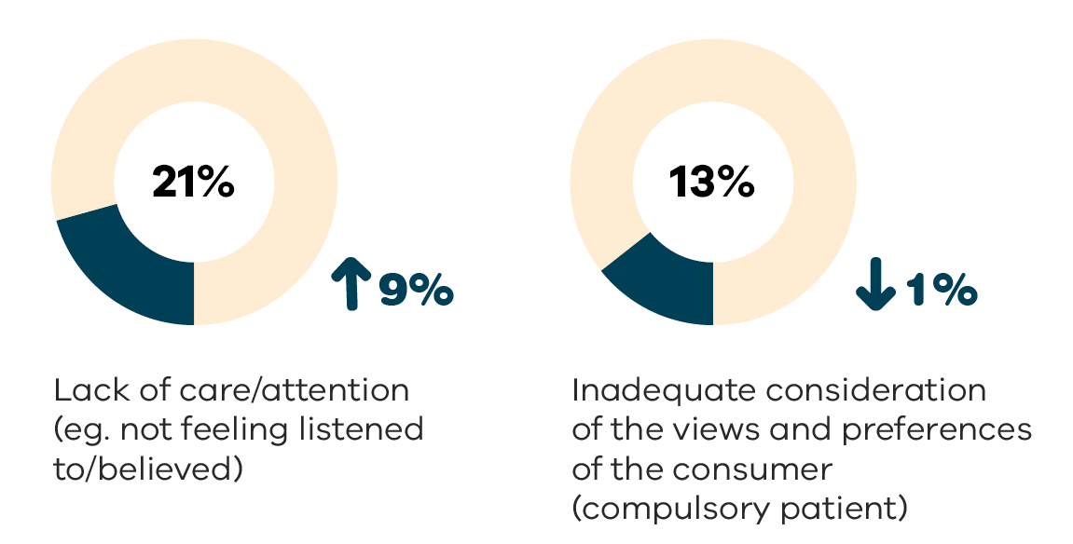
Data table for figure 7
Level 3 issue | Percentage | Change from 2020/21
Lack of care/attention (eg. not feeling listened to/believed) | 21% | Increased 9%
Inadequate consideration of the views and preferences of the consumer (compulsory patient) | 13% | Decreased 1%
Figure 8: Frequently raised level 3 communication issues
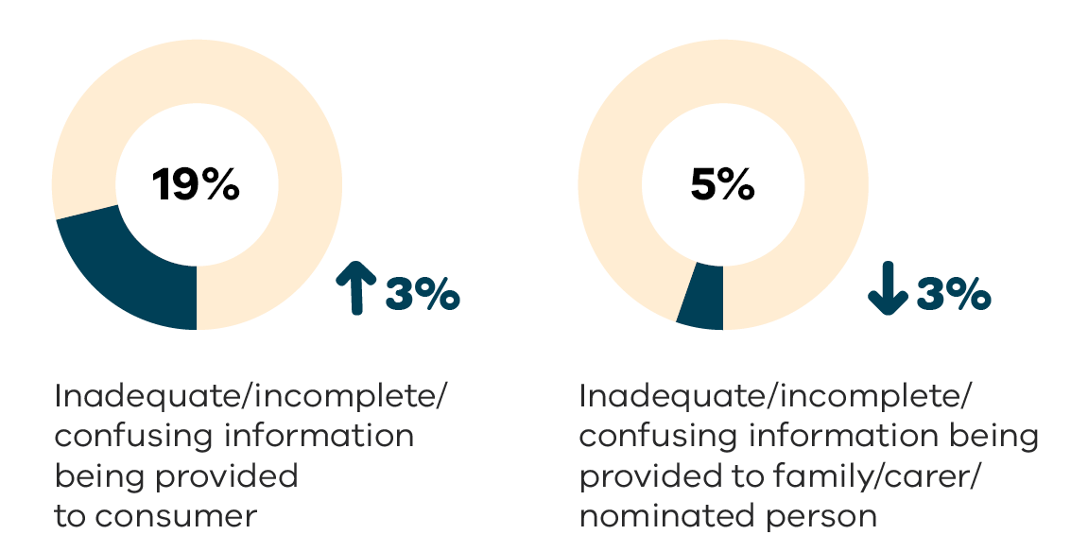
Data table for figure 8
Level 3 issue | Percentage | Change from 2020/21
Inadequate/incomplete/confusing information being provided to consumer | 19% | Increased 3%
Inadequate/incomplete/confusing information being provided to family/carer/nominated person | 5% | Decreased 3%
Figure 9: Frequently raised level 3 medication issues
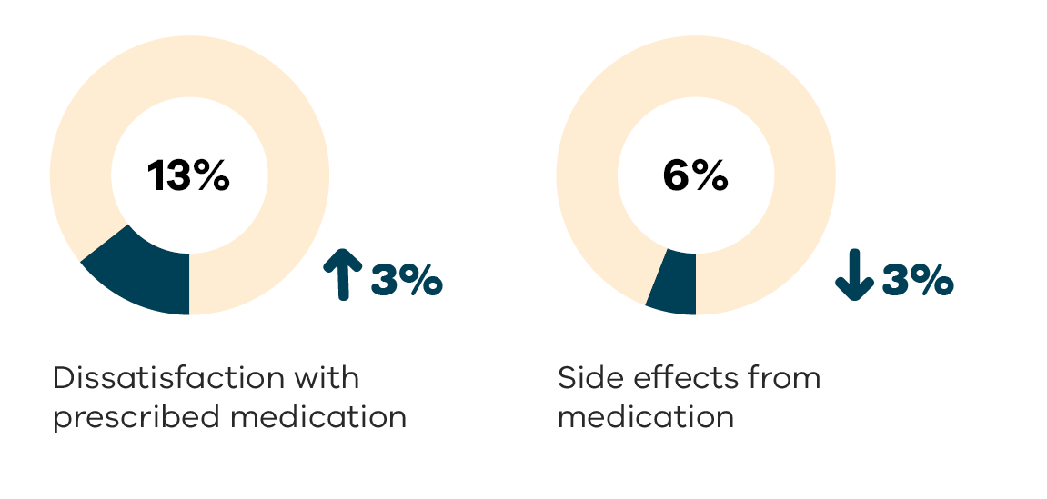
Data table for figure 9:
Level 3 issue | Percentage | Change from 2020/21
Dissatisfaction with prescribed medication | 13% | Increased 3%
Side effects from medication | 6% | Decreased 3%
Figure 10: Frequently raised level 3 conduct and behaviour issues
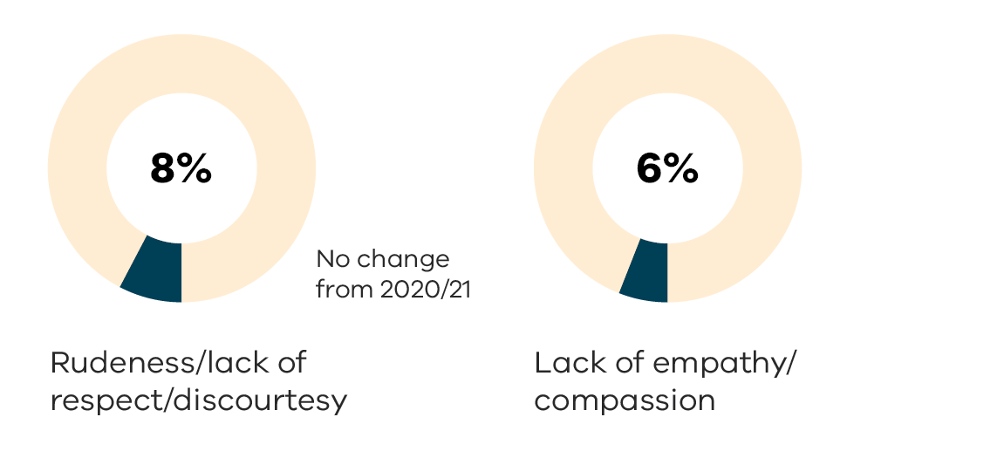
Data table for figure 10:
Level 3 issue | Percentage | Change from 2020/21
Rudeness/lack of respect/discourtesy | 8% | No change from 2020/21
Lack of empathy/compassion | 6% | Unknown
Figure 11: Frequently raised level 3 diagnosis issues
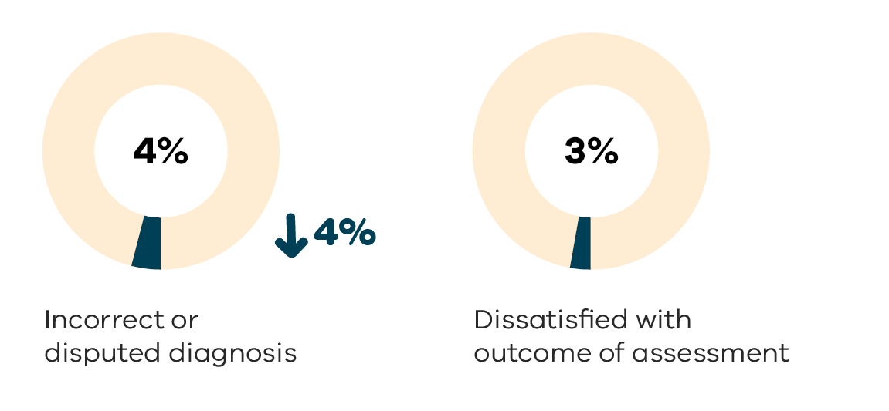
Data table for figure 11:
Level 3 issue | Percentage | Change from 2020/21
Incorrect or disputed diagnosis | 4% | Decreased 4%
Dissatisfied with outcome of assessment | 3% | Unknown

Complaints related to COVID-19
The MHCC continued to receive complaints related to the ongoing impacts of COVID-19 through the year however, Figure 12 highlights a decrease in the number of complaints received. This decrease can be attributed to restrictions having been gradually eased across the state (72% less than 2019/20 and 64% less than 2020/21).
Complaints received still reflected some of the themes that arose from the previous years including:
- Consumers in inpatient settings being restricted to their rooms for example in cases where there is a COVID-19 outbreak in the unit or in other areas of the service
- Restrictions on visitors (or number of visitors) to inpatient units
- Restrictions on access to leave, including outdoor areas available for consumers who smoke.
Figure 12: In-scope complaints related to COVID-19 received by MHCC
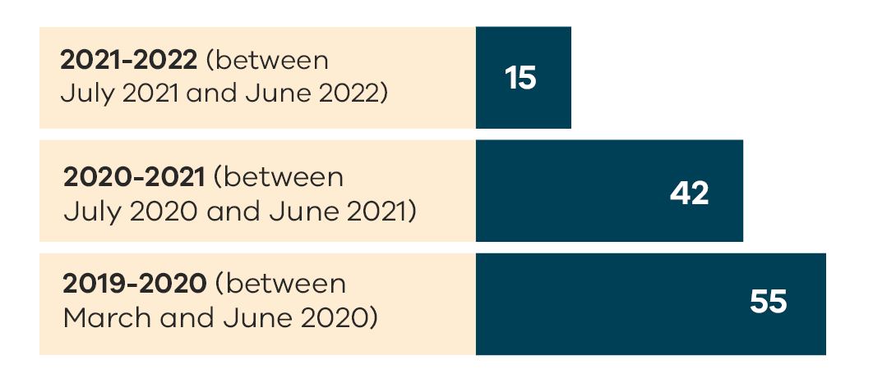
Data table for figure 12:
Year | Number of complaints
2021 to 2022 (between July 2021 and June 2020) | 15
2020 to 2021 (between July 2020 and June 2021) | 42
2019 to 2020 (between March and June 2020) | 55

Closure of complaints
In total, 1,551 complaints were closed by the MHCC this year.
Outcomes of closed complaints include 163 that were partially resolved, 95 that were fully resolved, 112 that were not resolved, and 1181 where a resolution was not applicable/reported. Among those where a resolution was reported, those fully resolved increased by 2% compared to 2020/21, and those partially and not resolved each decreased by 1% (see Figure 13). Resolutions are not reported when complaints are referred back to the mental health service provider for resolution and the MHCC is unaware of the outcome or when the MHCC is unable to contact the complainant before closing a complaint.
While the number of complaints where the resolution was either not applicable or has not been reported has decreased from the previous year, the percentage increased. This may be attributed to a change in our approach in facilitating more complaints to be dealt with by the services directly.
Figure 13: How many complaints were resolved
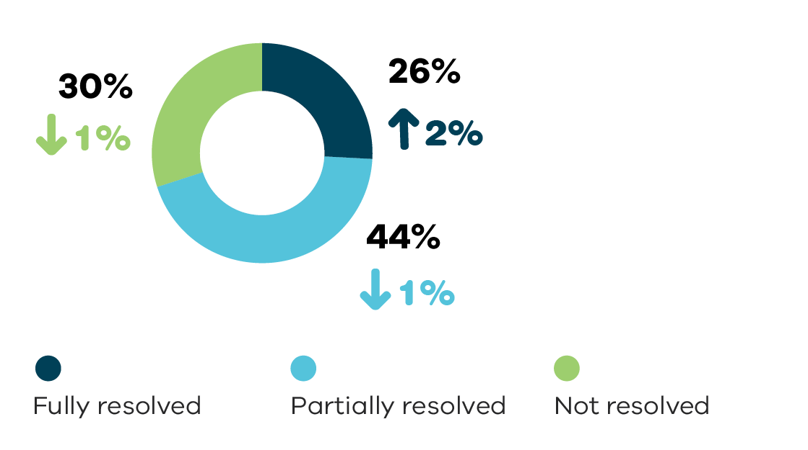
Data table for figure 13:
Status | Percentage | Change from 2020/21
Fully resolved | 26% | Increased 2%
Partially resolved | 44% | Decreased 1%
Not resolved | 30% | Decreased 1%
To gain further information on the outcome of complaints referred to services, the MHCC has introduced an additional step in our process (see page 29) which will require services to report back on the outcome of complaints that we referred to them by the MHCC.
From the in-scope complaints closed this year, 988 (63%) were finalised within one month of the complaint being received, 1399 (89%) within 3 months and 1467 (93%) within 6 months (see Figure 14). The time in which the MHCC closed complaints was similar to the previous year. Only 104 (7%) of the complaints closed took longer than 6 months to finalise.
Figure 14: How long did it take to finalise complaints
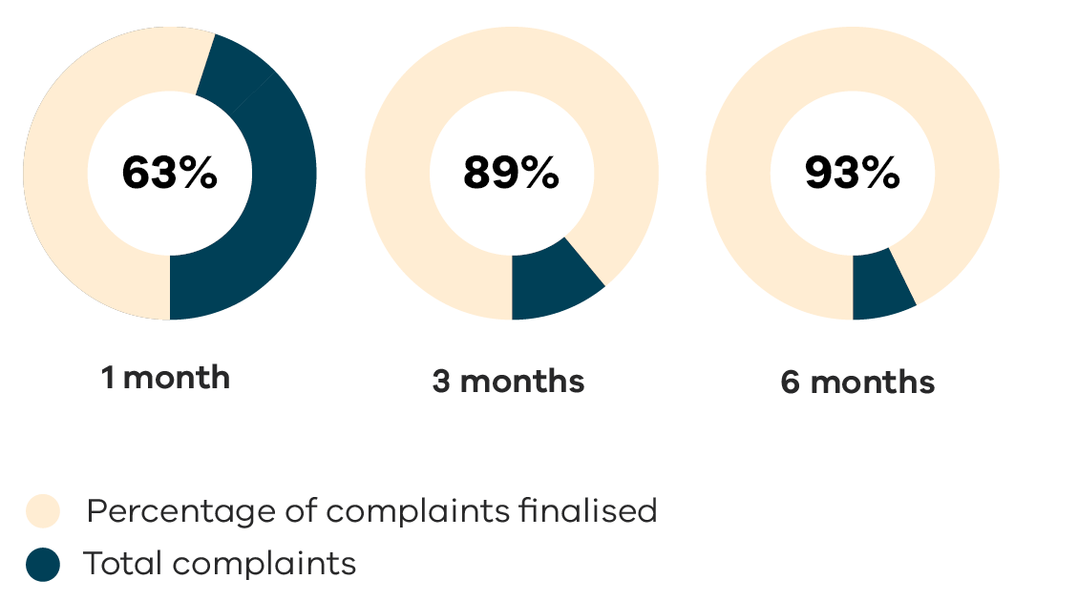
Data table for figure 14:
Length of time | Percentage of complaints finalised
1 month | 63%
3 months | 89%
6 months | 93%
* Some complaints that were closed in 2021/22 were carried from the previous reporting year and some of the ones received this year are still open.

Outcomes
The MHCC records outcomes of complaints using the 4 As of complaint resolution, noting that complaints may have more than one outcome. These include Acknowledgement, Action, Answer and Apology.
The MHCC acknowledges all complaints made and aims to support consumers and their families and carers in raising concerns with services and achieving meaningful outcomes with the services (guided by the 4 As model).
The most common actions taken by services to address individual concerns were responding to the complaint directly, addressing communication issues between the complainant and the service, making changes in the service provided to the consumer and meeting with the consumer, their family or carer to explore resolving issues. Additional information about the actions services have taken is available in the recommendations and service improvements section on page 32.

Figure 15: What did services do when people made complaints?
Image transcription:
523 Acknowledgement of a person’s experience.
312 Answers or explanations about the complaint issues.
249 Actions taken because of the complaint.
97 Apology for the person’s experience.
End transcription.

What did 2021/22 teach us?

Local complaints reporting
This year the MHCC has received data provided by all public mental health services in Victoria about complaints made to them directly. The MHCC produces reports that compare the complaints received by each service to complaints received across the sector, and to complaints made directly to the MHCC about the service.
These reports are designed to assist services to identify emerging challenges or strengths, to identify areas they have improved in, and areas where further progress can be made. Additionally, the MHCC publishes information from these reports to promote collaboration between services. The MHCC encourages services to see the areas where they could improve, compared to the sector, and we promote communication between services with a view to increased consistency across the sector.
As in previous years, the 2020/21 data shows that, in general, more complaints were made directly to services than to the MHCC. The MHCC has worked on supporting services to ensure a positive complaints culture and promote local complaint resolution through the development of our Complaints Self-assessment Tool for services (see page 27) and the ‘It’s OK to Complain!’ campaign (see page 26).
Later in 2022, the MHCC will publish the state-wide complaints data charts and narratives, including comparative compliments and complaints charts, as well as the service summary reports for 2020/21 on our website.

Staff training
As part of our strategic objective to prepare for change and build capability, we delivered a number of activities aimed at developing the skills and capabilities of our staff and supporting better decision-making at all levels of the organisation.
All MHCC staff participated in monthly training by various mental health organisations. Training was provided across a range of priority areas such as LGBTQI+ Trans Allyship, family violence awareness, cultural sensitivity awareness, and vicarious
trauma awareness.
Our resolutions and investigations teams participated in monthly reflective practice, led by a senior resolutions officer, and regular complaint review activities which develops in-depth familiarity with practice guides and mental health legislation. Our internal governance processes encourage lateral learning between peers and build confidence in decision-making. We also held reflective practice discussions about lived experience which were led by our Senior Advisor, Lived Experience. We continue to invest in supporting the professional development of all staff across the office, and to prepare for the transition to the MHW Commission.

How our Advisory Council was involved in this work
Two members of the Advisory Council presented at a session for MHCC staff where they spoke about their lived experiences with the mental health system and mental health services.

How we help

Complaint examples
The following pages include examples of complaints. Some of these examples may be triggering and we advise caution to readers.
Please note: names and identifying details in these complaint experience stories have been omitted or changed to protect the identity of those involved.

Emily

What Emily told us
Emily is a young Aboriginal adult. She made a complaint to the MHCC after she was discharged by the community team of a regional mental health service. Emily felt she had been discharged without appropriate supports put in place to assist her. She said her mental health had deteriorated, and when she tried contacting the service, she was repeatedly turned away. She felt unsupported and confused about where else she could go to access mental health supports.

Emily’s rights
The relevant mental health principles include:
providing the best possible therapeutic outcomes and promoting recovery and full participation in community life (s 11 (b))
involvement in decisions and respect for views and preferences (s 11 (c))
Aboriginal culture and identity recognized and responded to (s 11 (h)).

What we did
The MHCC wrote to the service and attached a copy of Emily’s written complaint. With Emily’s consent we asked the service to contact her directly to discuss her concerns. We then followed up on the outcome with Emily and the service.

Outcomes
A manager from the service spoke with Emily about her concerns, and together they reviewed the care plan that had been developed before her discharge which included referrals to community Aboriginal services, family supports, and private counselling. The discussion enabled Emily to gain a better understanding of the role of the mental health service, and she was reassured that she could contact the service if she is in a crisis or requires additional supports.
Emily told us that she appreciated the MHCC’s involvement in assisting her and that she was happy with the outcome.

Adhira
Trigger warning: please note this complaint experience includes an incident of restraint.

What Adhira told us
Adhira made a complaint to the MHCC about her experience when she agreed to a voluntary inpatient admission to receive Electroconvulsive Therapy (ECT). This was her first admission to a public mental health inpatient unit and her first experience of receiving ECT. Adhira said that in the inpatient unit her belongings were searched, items were removed from her, she was placed on a Compulsory Treatment Order and she was physically restrained by staff. She said the restraint was not necessary and she was not treated with dignity and respect.

Adhira’s rights
The provisions of the Act relating to compulsory treatment, consent to treatment, and restrictive interventions are relevant to this complaint. A number of principles also apply, including:
- providing assessment and treatment in the least restrictive way possible (s 11 (a))
- providing the best possible therapeutic outcomes and promoting recovery and full participation in community life (s 11 (b))
- respecting and protecting a person’s rights, dignity and autonomy (s 11 (e)).

What we did
The MHCC formally accepted the complaint and conducted a detailed review of the issues. We arranged a teleconference with senior clinicians from the service to discuss the issues raised, and steps that could be taken to resolve the complaint and make service improvements.

Outcomes
The service acknowledged that Adhira had not been given an adequate explanation before her admission about what to expect, including the restrictions that apply in an inpatient setting. After her admission, staff were concerned that Adhira had items that could pose a risk to other consumers. The service acknowledged that staff did not communicate this effectively and that the situation unfortunately escalated, leading to compulsory treatment and restraint.
The service provided a written apology to Adhira, and offered to have a meeting with her, which she declined. The service recognised an opportunity to improve their process and made a service improvement to the admission process for consumers receiving ECT as a voluntary patient. The revised process will ensure consumers understand what to expect and agree to the restrictions that apply in an inpatient setting.

Alice

What Alice told us
Alice is a survivor of family violence. During this time, her pet was a source of companionship and strength, and she says he got her through some of the most trying times of her life. When her pet passed away this had a significant impact on Alice’s mental health and wellbeing, and she went to the emergency department at her local hospital.
She felt a staff member was dismissive of the relationship she shared with her pet, using this to minimise the impact of his death on her wellbeing.
Alice raised these concerns directly with the service, however she felt the response provided further contributed to her feeling that her grief was not taken seriously.

Alice’s rights
The relevant mental health principles include:
- providing the best possible therapeutic outcomes and promoting recovery and full participation in community life (s 11 (b))
- recognising and responding to individual needs, including disability (s 11 (g)).

What we did
The MHCC wrote to the service and provided a copy of Alice’s written complaint. The service advised that a written response had been sent directly to Alice. We reviewed the response and suggested that the service could provide a further response that specifically recognizes the relationship with her pet to her health and wellbeing, which the service agreed to.

Outcomes
Alice received a written apology and acknowledgment from the service’s clinical director. Alice said she felt the letter offered a genuine recognition of her trauma. She thanked the MHCC for speaking up for her and for validating and acknowledging the impact of the death of her pet. She was pleased she could use her voice to make a difference for future consumers accessing the service.

Kim

What Kim told us
The MHCC received a complaint from Kim’s father about her recent experiences with the emergency department of a metropolitan hospital. As part of our assessment, we also spoke with Kim who told us she had been ‘in and out of hospital’ due to her mental health condition. She said she contacted 000 whenever she was unwell and was taken to the ED by police or ambulance. When this happened recently, Kim said she had been sent home after being seen by staff in the ED. This left her feeling unsafe as she felt she did not have sufficient community and NDIS supports to maintain her wellbeing.

Kim’s rights
The relevant mental health principles include:
- providing the best possible therapeutic outcomes and promoting recovery and full participation in community life (s 11 (b))
- involvement in decisions and respect for views and preferences (s 11 (c))
- recognising and responding to individual needs, including disability (s 11 (g)).

What we did
The MHCC worked with Kim, her father, and her advocate to progress the complaint. We held a teleconference with senior clinicians to discuss the issues raised. Following the teleconference, we had several discussions with the manager of the community team and made suggestions for how the service could improve communication with Kim and for a plan to manage the response of the services involved in her care.

Outcomes
The service developed an Emergency Management Plan in collaboration with Kim. The Plan included a communication component to enable Kim to provide and receive updates from her care team on a regular basis. It also listed agreed steps that should be taken by ambulance and police should a call be made by Kim. The service told us that the revised plan enabled increased collaboration with Kim.
The service said that the MHCC’s role in achieving this outcome was helpful and Kim told us her anxiety had decreased now that she felt more involved in her care.

Daisy

What Daisy told us
Daisy called the MHCC to raise concerns about the care provided to their father who was on a compulsory treatment order in an aged persons’ inpatient unit. Daisy believed their father’s daily living needs were being neglected. They also observed staff being rude and disrespectful to other consumers.
Daisy had made a local complaint, to which they received a written response, however several weeks had passed without any improvements being made.

Daisy’s father’s rights
The relevant mental health principles include:
- providing the best possible therapeutic outcomes and promoting recovery and full participation in community life (s 11 (b))
- respecting and protecting a person’s rights, dignity and autonomy (s 11 (e))
- recognising and responding to individual needs, including disability (s 11 (g)).

What we did
The MHCC arranged a teleconference with senior clinicians from the service to discuss the issues raised, and they told us they escalated the complaint to the service’s executives due to the seriousness of the issues raised. The MHCC referred the concerns about the behaviour of specific staff members to the Australian Health Practitioner Regulation Agency. AHPRA deals with complaints about the conduct of registered health practitioners.
As some of the concerns potentially affected other consumers the MHCC contacted the Office of the Chief Psychiatrist (OCP) about the concerns Daisy had raised, and the steps taken. We continued to meet with the OCP to share information about further steps taken by the service and the MHCC in response to the complaint. The MHCC also requested that staff at the Community Visitors Program of the Office of the Public Advocate monitor the service by undertaking more frequent visits to the service.

Outcomes
The service acknowledged deficiencies in the care provided to Daisy’s father and the seriousness of the issues raised about staff conduct. The service provided an apology to Daisy and advised that disciplinary action had been initiated in relation to a staff member. The service also advised of other improvements to address the culture of the unit, including increased staffing on the unit, training for staff (developed in collaboration and with the leadership of the OCP), and forums for staff to raise concerns with the leadership team.
Daisy told us that they were pleased about the changes made by the service and that they were reassured that consumers would be treated in a way that is safe and respected their dignity.

Peter

What Peter told us
Peter’s complaint was referred to the MHCC by the Independent Mental Health Advocacy (IMHA) Program while he was an inpatient at a mental health service. He said that his treating team prescribed and administered a new medication without his consent, resulting in physical side effects.

Peter’s rights
The provisions of the Act relating to compulsory treatment and consent to treatment are relevant to this complaint.
A number of mental health principles also apply, including:
- providing the best possible therapeutic outcomes and promoting recovery and full participation in community life (s 11 (b))
- involvement in decisions and respect for views and preferences (s 11 (c))
- respecting and protecting a person’s rights, dignity and autonomy (s 11 (e)).

What we did
The MHCC obtained further information from Peter and provided a summary of his concerns to the service. We requested that a staff member speak to Peter about the medication and ways to resolve the issues raised. We asked that both Peter and the service let us know the outcome of the local resolution.

Outcomes
The service told us that the treating team had discussed the new medication with Peter prior to the change in accordance with their policies on shared decision-making. Staff acknowledged that Peter was unwell at the time of the discussion and recognised the importance of continuing discussions with consumers about consent to medication. The treating team apologised directly to Peter acknowledging that he did not feel he had been involved in the decision and spent time with him to discuss his treatment options and medication preferences.
Peter told us that he felt heard and validated. Following these discussions Peter’s medication was changed back to a prescription that he was happy with. He also told us that the service planned to create a new space on the walls of the inpatient unit to display information about how consumers can make complaints.

Ava

What Ava told us
Ava called the MHCC while she was on a compulsory treatment order in an intensive care unit at a mental health service. During the course of her admission, one of her best friends passed away. She felt that the staff were not supporting her in her grief, nor was she being provided with any options to be granted leave to attend the funeral. She said she did not know what her rights were because she had not been provided with a statement of rights upon the making of the Assessment Order.

Ava’s rights
The Act states that a person must be given a copy of an Assessment Order when it is made and a copy of the relevant statement of rights (s 32).
The mental health principles that apply include:
- providing assessment and treatment in the least restrictive way possible (s 11 (a))
- providing the best possible therapeutic outcomes and promoting recovery and full participation
in community life (s 11 (b))
- respecting and protecting a person’s rights, dignity and autonomy (s 11 (e))
- involvement in decisions and respect for views and preferences (s 11 (c)).

What we did
The MHCC summarised Ava’s concerns and sent her complaint to the service with a request that a staff member speak to Ava about the issues raised. We asked the service to let us know the outcome. We followed up with the service the issue of whether a statement of rights was provided to Ava as this is a legislative requirement.

Outcomes
The service told us that the manager of Ava’s treating team had a discussion with her and acknowledged her experience and provided an apology.
The service reviewed Ava’s file and identified that when she was placed on an Assessment Order there was a record of her being given a copy of the order, however it was not recorded whether she was given a copy of the statement of rights. In contrast, there was a record of Ava being given a copy of the order and the statement of rights when she was placed on a Temporary Treatment Order. The service told us it would reinforce to staff the requirement to provide the statement of rights and to record that it was provided in the clinical record. Ava was satisfied with the outcome of her complaint.

Novak

What Novak told us
Novak made a complaint to the MHCC about the care provided to his elderly mother following a fall at an aged mental health unit. Novak was concerned that there was a delay in appropriate medical treatment being provided to his mother, as staff believed her subsequent physical deterioration was due to mental illness rather than an injury from the fall. Novak also felt that the family’s views about his mother’s care had not been considered by staff during the admission. Novak’s mother had passed away several months after the admission from other health complications.

Novak’s rights and his mother’s rights
The following mental health principles are relevant to the experiences of Novak and his mother:
- providing the best possible therapeutic outcomes and promoting recovery and full participation in community life (s 11 (b))
- recognising and responding to a person’s medical and other health needs (s 11(1)(f))
- carers (including children) for persons receiving mental health services should have their role recognised, respected and supported (s 11(1)(l)).

What we did
The MHCC requested a written response from the service. The service confirmed in the response that a clinical review had been completed following the admission and that service improvements had been implemented. The service invited Novak and his family to meet with the staff to discuss their experience.

Outcomes
Novak and his family met with staff at the service by video conference. Staff apologised to the family, provided further information about improvements implemented and invited the family to assist in the development of a case study about their experience for staff training purposes.
The service confirmed that staff had reviewed their policy about treatment and care for people who have fallen to ensure consistency with contemporary practice and provided education to staff about the clinical pathways for rapid deterioration of physical health. An access pathway to medical and surgical care had been developed to ensure consumers in mental health units had timely access to medical care. Novak confirmed the family had felt heard by staff and were satisfied that appropriate improvements had been implemented in response to their mother’s experience.

How We Safeguard

Creating a positive complaints culture
During 2021/22 the MHCC developed and launched a series of initiatives that focused on creating a culture of ‘Making it OK to complain’. We also led and participated in a wide range of education and engagement activities aimed at increasing awareness and understanding of the MHCC and its processes.

‘It’s OK to Complain!’ campaign
Everybody has the right to make a complaint about a public mental health service in Victoria. In April we launched the ‘It’s OK to Complain!’ campaign which aims to challenge the stigma that exists around making a complaint and encourages consumers, carers and families to speak up to help improve their experience and the system for everybody.
The campaign included the development of a series of posters and postcards that were distributed to mental health services, as well as a social media series and web content.
The printed materials were targeted to different audience groups and included QR codes that linked to a series of videos. The videos featured consumers from first nations peoples, LGBTIQ+, youth, older people, and carers. We also developed videos for mental health services staff with two clinicians speaking about why it is OK to encourage consumers and carers to complain.
This campaign supports the MHCC’s view that complaints are a valuable opportunity to raise awareness, tackle stigma and drive continuous improvement across Victoria’s public mental
health system.

How does lived experience drive and inform our work?
- Working in partnership with our Lived Experience Advisory Council
- Using our Lived Experience Engagement Checklist
- Using co-design to work in partnership with people with lived and living experience
- Ensuring staff in designated roles as well as those with a declared lived or living experience are involved in projects
- Recording feedback from workshops and meetings from people with lived or living experiences that can inform current and future work
- People with lived and living experience play a range of roles in problem definition and decision making processes
- Seeking feedback and input from peak consumer and carer bodies including VMIAC and Tandem Carers
- Embedding designated lived experience roles in the MHCC’s Leadership Group

Lived Experience Engagement Checklist
The Royal Commission into Victoria’s mental health system identified the need to build a better system for the future that is informed by the experiences and perspectives of those who rely on it. To do this, it is necessary to address power imbalances and combine clinical knowledge with a diversity of lived experience perspectives so we can work together to improve the system.
The MHCC’s Lived Experience Engagement Checklist has been designed to support staff working in the public mental health sector in their efforts to maximise their engagement and collaboration with people with lived experience in project and policy work, consultations, and collaborations.
The checklist is not an audit of public mental health services, rather it is an opportunity for staff to self-assess the levels of engagement, collaboration and participation with lived experience within a service.
So far, feedback from mental health service staff who have used the checklist has been extremely positive and we look forward to seeing increased engagement and collaboration with people with lived and living experience of mental health issues in services.

Complaints Self-Assessment Tool
One of MHCC’s roles is to work with public mental health services to improve their local complaints processes so that consumers and carers can feel more confident complaining to services directly.
In-line with our Driven by Lived Experience Framework and Strategy, the Complaints Self-Assessment Tool has been co-designed with lived experience representatives, and in close consultation with stakeholders across Victoria’s public mental health services.
The tool enables all staff involved in the complaints process to self-assess and better understand their organisation’s local complaints processes and identify opportunities to make improvements within the service.
The tool helps services examine all parts of their complaints process, share good practice examples and ideas with one another, and compare change over time and across the sector. On completion, a personalised report can be generated for each respondent containing examples of good practice as well as materials and ideas to support continuous improvement actions.
Since its launch, the tool has already been used over 200 times by public mental health services across Victoria.

Education and engagement
The MHCC has an education and engagement function under the Act. This includes making its complaints procedure available and accessible to everyone and providing information, education and advice to Victorian public mental health services about their responsibilities in managing complaints.
This year the MHCC used the information gathered from listening to people’s lived experiences and complaints to guide the development of education and engagement activities, and clear and inclusive communications.
The MHCC wants consumers, families and support people to know they have a right to speak up, and we encourage them to feel confident and safe to contact us.
This year the Commissioner and members of the MHCC team:
- Provided input into the new MHW Act and the establishment of the new MHW Commission
- Held quarterly meetings with services across Victoria
- Participated in the Joint Commissioners Meeting on a monthly basis
- Launched the ‘It’s OK to Complain!’ campaign and undertook roadshows to various regional and metropolitan services to disseminate materials and educate, consumers, carers and staff
- Launched the Complaints Self-Assessment Tool and the Lived Experience Engagement Checklist
- Presented at the 2021 TheMHS Annual Conference
- Participated and presented at quarterly meetings with IMHA, VMIAC and Tandem
- Participated in quarterly meetings with the
Office of the Chief Psychiatrist and contributed
to other meetings and forums convened by the Chief Psychiatrist
- Released regular e-bulletins and social media content across four platforms (Twitter, Facebook, Instagram and LinkedIn)
- Joined the judging panel for the 2021 Tandem Awards and the 2022 Volunteering Awards
- Led an online workshop series introducing our new assisted referrals process (highlighted on page 29)
- Visited 19 inpatient units across Victoria with remaining sites to be scheduled after COVID-19 Winter measures are lifted in Spring 2022
- Held discussions with The Bouverie Centre about trauma informed practice
- Provided input into the Mental Health and Wellbeing Workforce Capability Framework
- Represented at Women’s Mental Health Alliance meetings and Victorian Aboriginal Community Controlled Health Organisation meetings
- Participated in the Chief Commissioner of Police’s Human Rights Strategic Advisory Committee
- Participated in the Department’s Advisory Group about the Duty of Candour
- Contributed to other government consultation processes, including in relation to legislative proposals.
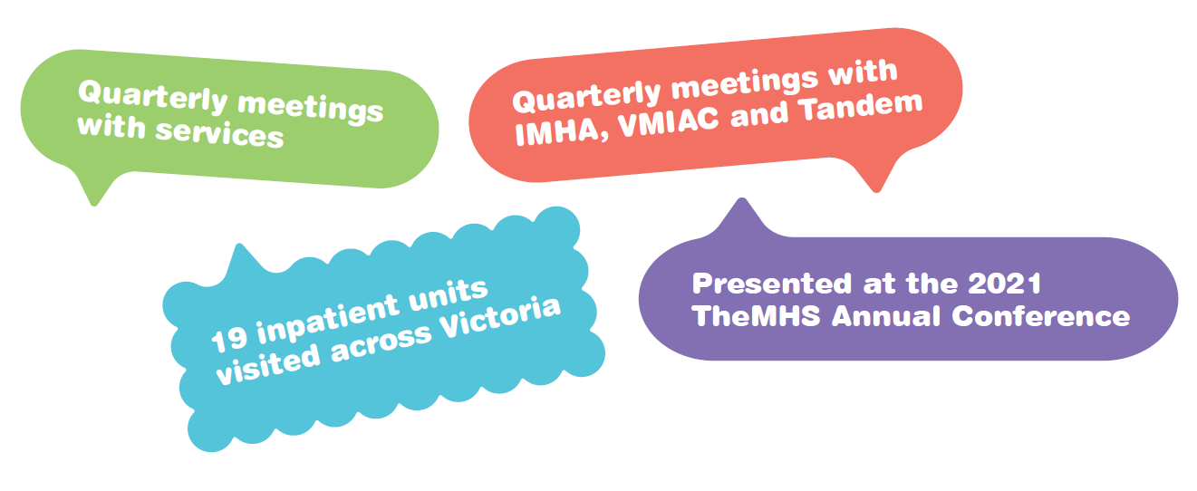

Our new assisted referral process
Resolving complaints quickly is often better for consumers, carers and services. To facilitate early resolution, we continued to refine our practices. From July 2022, with the consumer’s consent the MHCC will provide services with the opportunity to resolve complaints locally as long as the complaint does not involve serious safeguarding issues.
The assisted referral process will involve the referral of appropriate complaints to the service so that they can work to resolve the complaint directly with the consumer or carer. The new part of the process is that services will be required to tell us what happened and if the issue has been successfully resolved, to ensure this work is reflected in our data and reporting.
Figure 16: The assisted referral process
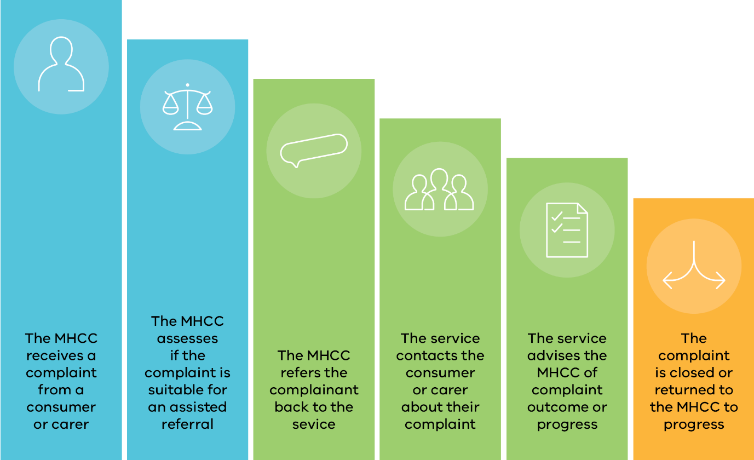
Image transcription:
- The MHCC receives a complaint from a consumer or carer
- The MHCC assesses if the complaint is suitable for an assisted referral
- The MHCC refers the complaint back to the service
- The service contacts the consumer or carer about their complaint
- The service advises the MHCC of complaint outcome or progress
- The complaint is closed or returned to the MHCC to progress
End transcription

Our work around the use of restrictive interventions
The MHCC continued to prioritise the assessment and response to complaints about the use of bodily restraint and seclusion. These practices are referred to as ‘restrictive interventions’ in the Act. They can only be used in strictly limited circumstances as set out in the Act and subject to the statutory safeguards and protections.
In 2021/22 the MHCC received 52 complaints which raised issues about the use of restraint and seclusion. When we receive a complaint about the use of restraint or seclusion we will usually conduct a detailed review, including an assessment of whether the requirements of the Act have been met along with the expectations of the Chief Psychiatrist’s guideline Restrictive interventions in designated mental health services.
The MHCC continues to receive complaints about the use of restrictive interventions where services have been unable to demonstrate that all of the requirements for the use of such measures were met. We worked with a number of services to further develop improvements in this area, including:
- monitoring the response by services to recommendations made by the MHCC as part of formal investigations about the use of restraint
- liaising with a service to progress implementation of steps agreed as part of an undertaking, including the development of a mandatory online training module for all clinical staff in relation to restrictive interventions
- strengthening the importance of the role of qualified mental health staff when restraint is used in the emergency department or a medical unit, including oversight by mental health consultation liaison staff
- Improving how electronic medical records and workflows can support clinicians to ensure legislative requirements are met and can be verified.
To strengthen and streamline our oversight we developed a questionnaire about the use of bodily restraint under the Act in relevant complaints. We anticipate this new step will reduce the time and effort spent by the MHCC in reviewing clinical records to assess compliance with the Act and the Chief Psychiatrist’s guidelines. We also expect it will improve understanding within services of the requirements for the use of restraint and strengthen the capacity of services to undertake comprehensive reviews and to monitor the impact of any initiatives to reduce use. We are working on a similar questionnaire for complaints about seclusion.
Under the Act, restrictive interventions can only be used in strictly limited circumstances.
The following example outlines how the MHCC worked with a consumer and a service to respond to a complaint about the use of mechanical restraint, and the improvements resulting from an enforceable undertaking.

Complaint example

Sam
Please note: this complaint example includes
an incident of mechanical restraint.

What Sam told us
Sam made a complaint to the MHCC about their experience of being mechanically restrained. Sam told us that the restraint was continued for several hours after they had become calm and settled.

Sam’s rights
Restrictive interventions (restraint and seclusion) are regulated by Part 6 of the Act. They can only be used in limited circumstances.
Section 109 of the Act requires that a person who may authorise the use of a restrictive intervention and is satisfied the continued use of the restrictive intervention is no longer necessary must immediately take steps to release the patient from the restrictive intervention. Staff who may authorise the use of bodily restraint include authorised psychiatrists, registered medical practitioners and the senior registered nurse on duty.
In addition, the Chief Psychiatrist’s guideline Restrictive interventions in designated mental health services states that a registered nurse or registered medical practitioner must consider the need to continue bodily restraint as part of their clinical reviews (which must be conducted not less than every 15 minutes).
The following mental health principles are relevant to Sam’s experience:
- providing assessment and treatment in the least restrictive way possible (s 11 (a))
- people receiving mental health services should have their rights, dignity and autonomy respected and promoted (s 11(1)(e)).

What we did
The MHCC requested a written response to the complaint and documentation for review, including the service’s internal review of the use of mechanical restraint. We then met with senior staff at the service via teleconference.
Sam’s clinical file did not record the reasons why medical practitioners and nursing staff conducting examinations and clinical reviews considered the continued restraint of Sam necessary for several hours. The clinical file rather recorded that Sam was mostly settled or asleep during this period. The service acknowledged it was unable to explain why staff continued the restraint during this period. The service’s internal review of the use of restraint had not considered this issue.

Outcomes
The service offered an apology to Sam for what they experienced during the episode of care.
The service agreed to provide an undertaking to the MHCC to take remedial action in response to the issues identified in the complaint, including to develop a mandatory online training module for all clinical staff in relation to restrictive interventions. The MHCC monitored the actions taken by the service pursuant to the undertaking.
The service confirmed to the MHCC that the training module had been developed and that clinical staff were progressively completing the module. The module educates staff in relation to the legislative requirements for the use of bodily restraint, the Chief Psychiatrist’s guideline, the human rights in the Charter, de-escalation strategies to minimise the use of restraint and delivering trauma-informed, gender sensitive and person-centred care.
The MHCC also made a recommendation for service improvement that further guidance be provided to staff conducting reviews of restrictive interventions about the factors which must be considered through any future complaints made to the MHCC.
The MHCC spoke with Sam throughout the complaint process. They were satisfied with the remedial actions taken by the service in response to their concerns, and the apology provided.
Please note: names and identifying details in this complaint experience story have been omitted or changed to protect the identity of those involved.

Our role in creating change

Recommendations and service improvements
During this year more than last year, services spoke regularly of the challenges they faced due to staff shortages and continued increasing demand. The MHCC adjusted some processes and ways of engaging with services to balance the need for concerns raised by consumers to inform and effect change, and for services to identify if issues were specific to the problems experienced due to COVID-19, or part of broader opportunities for improvement.
This year services reported a total of 65 service improvements in response to complaints and recommendations made by the MHCC. The total service improvements reported decreased from the 132 recorded last year. Most recommendations and service improvements focused on policies, procedures or practices, as well as on training or providing feedback to staff.
The predominant themes of these improvements were safety; rights, dignity and autonomy; and communication. Improvements were the outcome of the resolution process, including consultation with services about issues raised by complainants and issues identified by the MHCC, and proposals and recommendations made by MHCC.
Figure 17 shows the percentage of actions taken by services to create improvements reported over 2021/22. While Figure 18 shows the most common themes of the improvements made over the year.
Figure 17: Service improvements: actions taken
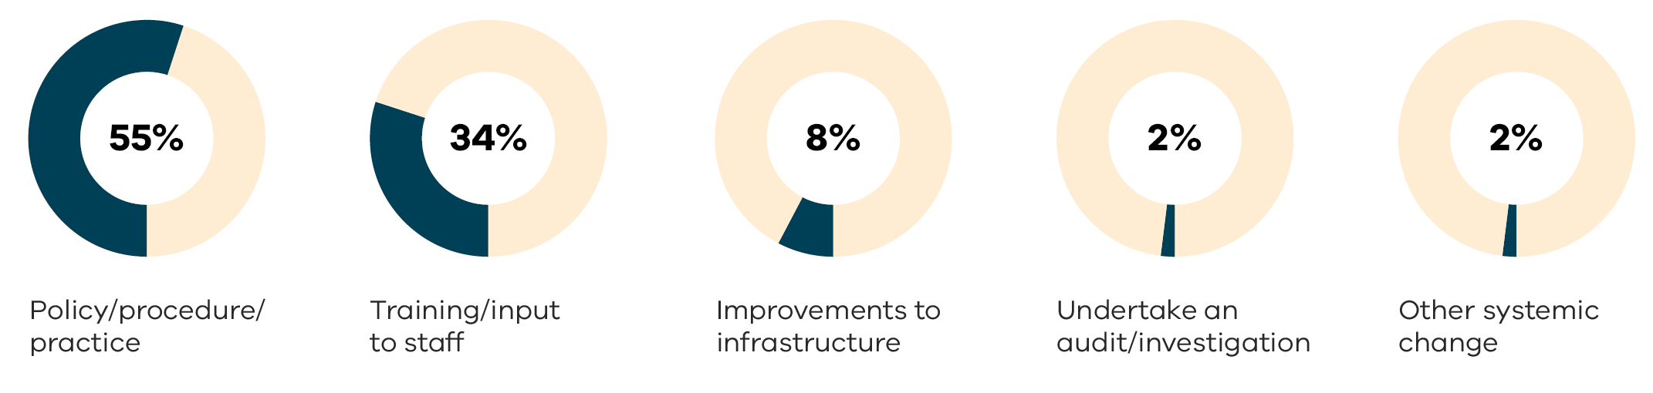
Data table for figure 17:
Actions taken | Percentage of actions taken
Policy/procedure/practice | 55%
Training/input to staff | 34%
Improvement to infrastructure | 8%
Undertake an audit/investigation | 2%
Other systemic change | 2%
Figure 18: Service improvements: themes
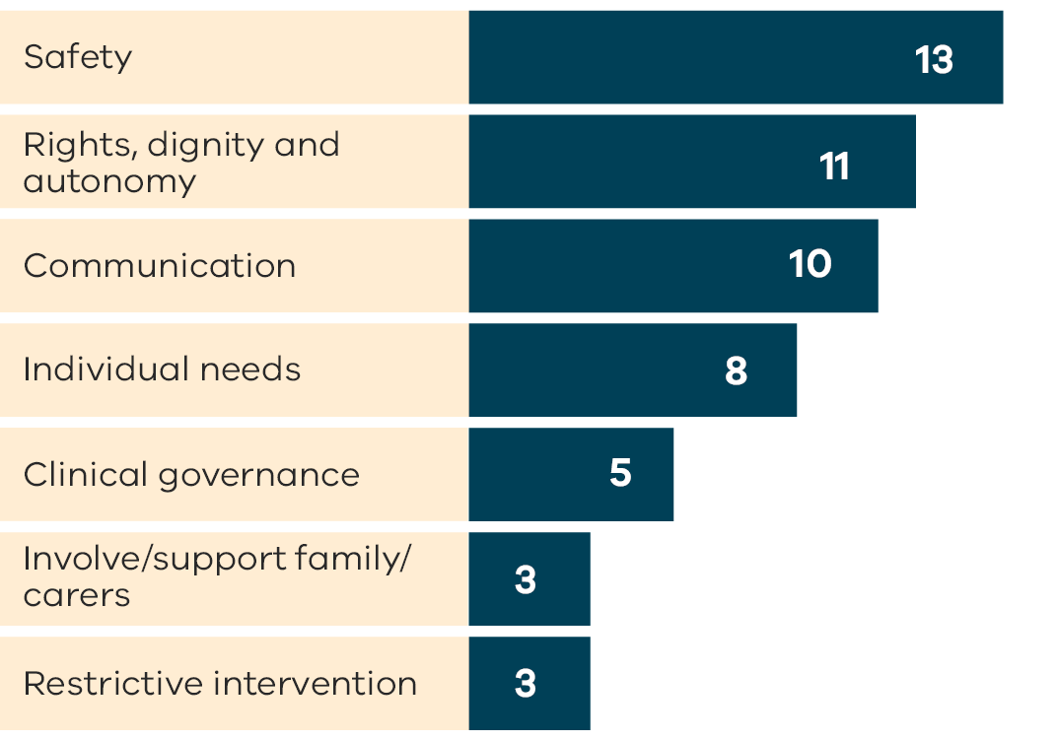
Data table for figure 18:
Theme | Number of improvements
Safety | 13
Rights, dignity and autonomy | 11
Communication | 10
Individual needs | 8
Clinical governance | 5
Involve/support family/carers | 3
Restrictive intervention | 3

Investigations
Investigations are an important part of the work of the MHCC. We consider a range of issues before deciding a matter should be formally investigated, including the seriousness of the issues raised, whether the anticipated outcomes can be achieved without an investigation, the likely costs and benefits of the investigation, and the impact on the consumer from a trauma-informed perspective. Formal investigations are time-consuming and require the MHCC to have regard to the legal rules of procedural fairness. In our experience we can often achieve significant outcomes in a timelier way by a less formal approach which may involve a detailed review of clinical records and other documents. This year we opened a new investigation about the experience of a young person who was secluded for several days.
In 2021/22 the MHCC closed five investigation matters. The five investigations covered a range of areas, including the use of physical and mechanical restraint, the making of Assessment Orders, electroconvulsive therapy (ECT), and allegations of assault, abuse and bullying by staff. The investigation reports for each of these matters were completed in previous years and included detailed recommendations for action that the service should take in response to the findings. The MHCC monitored implementation of the action required in response to the recommendations and closed the matters when we were satisfied appropriate remedial actions had been taken.

Our outreach

Service visits
During June and July 2022, the MHCC visited inpatient units throughout Victoria. These visits gave us the opportunity to strengthen relationships with services and better understand the current public mental health environments and the challenges being faced due to COVID-19.
Additionally, these visits presented an opportunity to promote the MHCC’s ‘It’s OK to Complain!’ campaign, Complaints Self-Assessment Tool and Lived Experience Checklist (detailed on page 26 and 27), as well as providing answers to questions about the complaints process to both staff and consumers who may be present. Our physical presence at inpatient units allowed us to distribute MHCC posters and postcards with QR codes that lead to our website to encourage consumers, carers and staff to learn more about the complaints process and contact us regarding their concerns.
Since these visits are ongoing, we hope to report on key themes more regularly. However, having already visited 19 inpatient units, some themes have started to emerge. These include:
- There is a lack of consistency between different services both in terms of infrastructure and the range of services provided. This is reflected in how both staff and consumers felt about the quality of care provided.
- Staffing issues are continuously affecting services’ ability to deliver basic services and additional support.
- There are notable variations in the type and number of lived experience and other liaison staff available at services.
- Through the MHCC’s campaigns, services are generally moving towards a positive complaints culture, where complaints are seen as valuable lived experience feedback that can often drive service improvements.
- There are opportunities for further support to encourage consumers to raise complaints directly to services.
- Services could make more use of resources the MHCC has made available. This was particularly apparent when discussing the Complaints Self-Assessment Tool.
The service visits have been a positive experience for both services, consumers, carers, lived experience workers and the MHCC. They have allowed us to better understand the type of support that can help to promote a positive complaints culture and it highlighted areas where the MHCC can provide further training and what actions and initiatives will allow complaints to be handled more effectively within in-patient settings. It has also been an opportunity to observe some great initiatives and to promote these approaches across the sector as we work to encourage more collaboration between services on continuous improvement.

Our community education and engagement activities
Our website and social media channels are recognised as key platforms when undertaking our education and engagement activities.
In 2021/22 the MHCC implemented a range of improvements and changes to provide more tailored, accessible and relevant content for consumers, carers and their family, as well as staff working in the public mental health system. This has delivered a significant increase in engagement across all our social media channels including:
211% more engagement on LinkedIn
180% more engagement on Twitter
88% more engagement on Facebook
88% more engagement on Instagram
These improvements also build on work from previous years including the MHCC’s updated website. A recent evaluation with users found it to be easier to navigate, more accessible and more representative of the diversity of the Victorian community.
By sharing relevant and tailored content on our website and social media channels for consumers, carers, families, and staff in public mental health services we:
- increase our accessibility and make it easier for consumers, carers and their families to make a complaint
- raise awareness about rights and principles under the Act
- demonstrate support for our stakeholders and the work of key organisations in the mental health sector.
- connect with staff across public mental health services to promote resources, education and other materials to support continuous improvement.

Our online engagement

Website
53,282 page views
20,614 sessions

Social media
2,200 LinkedIn followers
3,250 Facebook followers
1,700 Twitter followers
587 Instagram followers

Our most significant social media growth was on LinkedIn, with page view increases of over a 105%. LinkedIn also brought the highest percentage of users to the MHCC website where they can find more information, access resources and make a complaint.
Our social media outreach also included the ‘It’s OK to Complain!’ campaign social media kit providing downloadable images of social media tiles and content for audiences wanting to share information about the campaign on their social media channels and do their part to tackle stigma. Find out more about this campaign on page 26

Example post: Post for LGBTQIA+ audiences
Everyone has a right to have their say and feel respected, including LGBTQIA+ consumers, carers and support people. If you’re not happy about your experience, let [the service/us] know or contact the Mental Health Complaints Commissioner.
Contact [the service/us: link to service contact or complaints form/page].
Example of a downloadable social media tile:

During 2021/22, we also developed the ‘Rights and Principles’ social media series. The series was launched in July 2022 on our website and also promoted through our social media channels. The aim of this series is to promote awareness of the rights of people currently relying on the system, while work on new legislation and the formation of a new MHW Commission is underway.

A promising future
The Royal Commission into Victoria’s mental health system set a blueprint for a redesigned mental health and wellbeing system that delivers the best results for people living with mental illness and for their families and carers.
Through listening to consumer’s experiences, the MHCC has gained an insight into the problems with the present mental health system in Victoria that were identified by the Royal Commission. We hear that there are not enough services, that there is a shortage of inpatient beds, and that people seeking treatment are sometimes turned away due to demand or discharged too early. We also hear that the treatment and support options are limited and do not offer a holistic approach to recovery and that these pressures mean people may often be treated in a coercive way, including by compulsory treatment and the use of restraint and seclusion, which we hope will be avoided in a reformed system.
The MHW Commission will have a pivotal role in realising the Royal Commission’s vision. The new Commission will be responsible for ensuring the Government is accountable for the performance, quality and safety of the mental health and wellbeing system, that the system supports and promotes mental health and wellbeing, and that it protects the rights of consumers, families, carers and supporters. The MHW Commission will also provide a complaint handling system very similar
to the MHCC.
The Royal Commission made it clear that the role of the MHCC should be incorporated into the MHW Commission. Within our current scope and resources, we are already working to align our efforts with the Royal Commission’s recommendations wherever possible. As discussed in other parts of this report, we have strengthened and streamlined how we deal with complaints about restrictive interventions, and we are improving our data capture and reporting capabilities to make more information about complaints made to the MHCC and services available.
Further, we are developing a framework to deal with complaints about new service streams that become operational if they fall within the MHCC’s jurisdiction. For example, in response to the recommendations of the Royal Commission the Victorian Government is creating new Local Adult and Older Adult Mental Health and Wellbeing Services across Victoria. These services will be delivered through partnerships between public health services or public hospitals and non-government organisations that deliver wellbeing supports. The Victorian Government has announced the providers for the first six new Local Services that are expected to open by the end of 2022. The MHCC is preparing to engage with these new services to ensure that they develop appropriate processes for managing complaints and that consumers and their families and supporters are given information about how they can raise concerns to the service and the MHCC.
The MHCC is pleased that our knowledge and expertise in dealing with complaints and working to improve the mental health system can be built on by the new Commission.

Appendix 1:
Our operations

Financial statement for the year ended 30 June 2022
The Department provides financial services to the Mental Health Complaints Commissioner (MHCC).
The financial operations of the MHCC are consolidated into those of the Department and are audited as part of the Department accounts by the Victorian Auditor-General’s Office. A complete financial report is therefore not provided in this annual report.
A financial summary of expenditure for 2021/22 according to the Department accounts is provided below. The expenditure was less than the allocated budget of $5,835,347 due to the deferred activities and unexpected staff vacancies due to a range of factors, most notably the COVID-19 pandemic.

Operating statement for the year ended 30 June 2022
Expenses | Amount
Salaries and on-costs | $ 3,727,589
Contractors/external services | $ 199,250
Supplies and consumables | $ 524,832
Total expenses | $ 4,451,671

Staffing
There were 25.2 FTE staff (including fixed term positions) as at
30 June 2022, plus contractors engaged to perform specified functions and assist the MHCC to respond to the volume and complexity of complaints.

Appendix 2:
Our compliance and accountability

Privacy and Data Protection Act 2014 and Health Records Act 2001
The MHCC is subject to the Privacy and Data Protection Act 2014 in relation to the collection and handling of ‘personal information’ about individuals. ‘Personal information’ is recorded information that can identify a living person.
The MHCC must also comply with the Health Records Act 2001 when dealing with ‘health information’. This is information that can identify a person, including a person who has died, about the person’s physical, mental or psychological health, disability or genetic make-up.
The MHCC’s privacy policy explains how we deal with personal and health information and is available on the MHCC’s website at https://www.mhcc.vic.gov.au/privacy-personal-and-health-information

Freedom of Information Act 1982
Requests for access to documents held by the MHCC, or the correction of documents held by the MHCC can be made under the Freedom of Information Act 1982.
Applications can be made in writing to the MHCC at Level 26, 570 Bourke Street, Naarm/Melbourne VIC 3000 or by email to PrivacyFOI@mhcc.vic.gov.au.
In 2021/22 the MHCC made 6 decisions relating to freedom of information (FOI) applications. We also responded to an additional 8 requests for documents that were provided outside of the FOI process.

Charter of Human Rights and Responsibilities Act 2006
The Charter of Human Rights and Responsibilities Act 2006 sets out 20 fundamental human rights for all people in Victoria, including the right to be treated equally and to have our privacy respected.
The MHCC is a public authority under the Charter and is required to act compatibly with the human rights in the Charter, and to give proper consideration to Charter rights, in dealing with complaints and doing our work.

Public Interest Disclosures Act 2012
The Public Interest Disclosures Act 2012 encourages and assists people to report improper conduct by public officers and public bodies, and protects people from detrimental action as a result of making the disclosure.
Disclosures of improper conduct or detrimental action by the MHCC or its staff can be made to the Independent Broad-based Anti-corruption Commission (IBAC) or the Victorian Ombudsman.
Contact details are:

IBAC
Phone: 1300 735 135
Email: Info@ibac.vic.gov.au

Victorian Ombudsman
Phone: (03) 9613 6222
or 1800 806 314 (regional areas)
Email: complaints@ombudsman.vic.gov.au
Disclosures of improper conduct or detrimental action by the MHCC’s staff can also be made to the Department by email to publicinterestdisclosure@health.vic.gov.au or by calling the Department’s integrity unit on 1300 024 324.
More information about public interest disclosures is available on the IBAC’s website at ibac.vic.gov.au and the Victorian Ombudsman’s website at ombudsman.vic.gov.au/reporting-improper-conduct/.

Address: Level 26, 570 Bourke Street, Naarm / Melbourne, Victoria 3000
Phone: 1800 246 054 (free call from landlines)
Complaints: help@mhcc.vic.gov.au
General enquiries: info@mhcc.vic.gov.au
Website: mhcc.vic.gov.au
Twitter: twitter.com/MentalHealthCC
Facebook: facebook.com/mentalhealthcomplaintscommissioner
Instagram: instagram.com/mhcc_vic
LinkedIn: linkedin.com/company/mental-health-complaints-commissioner

