Training areas mapped to the mental health and wellbeing principles

The below matrix maps common training areas to the principles, to show where service training supports staff to work in ways that are compliant with the principles. Training should be codesigned and delivered with lived experience leadership to the greatest extent possible.
The matrix suggests three categories of training – core requirements (100% completion recommended), priority training (70% completion recommended), and speciality training (as needed). Core training includes training about the mental health and wellbeing principles and human rights. This is relevant to all staff in all service types and across all roles including managers and leaders, who must give proper consideration to the principles and to human rights in their decision making.
This is intended to be a supportive resource; services in consultation with lived experience workforce can add to it to reflect their needs.
Table 1: Principles mapped to core, priority and specialised training areas
 |  |  |  |  | 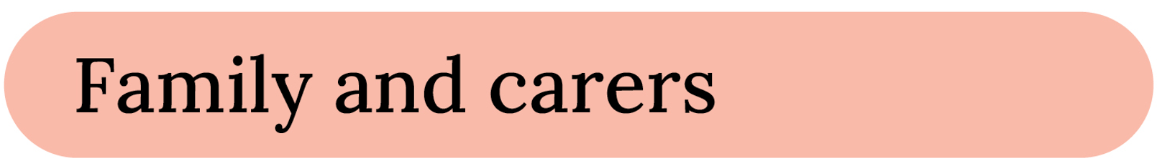 |  |  |  |  |  |  |  | 
Core training requirements (recommended completion 100% of ongoing staff)
Rights and Act requirements
MHWA training including:  - consumer rights under the Act including informed consent*  - role of carers and nominated support persons under the Act* | ✓ |  | ✓ | ✓ | ✓ |  |  | ✓
Mental health and wellbeing principles training  e.g. principles into practice, or other locally developed principles training | ✓ | ✓ | ✓ | ✓ | ✓ | ✓ | ✓ | ✓ | ✓ | ✓ | ✓ | ✓ | ✓
Supported decision making training  e.g. for example, IMHA’s supported decision making training | ✓ |  | ✓ | ✓ | ✓ | ✓ |  | ✓
Information sharing, privacy and confidentiality | ✓ |  |  |  | ✓
Training about rights and responsibilities under the Charter of Human Rights and Responsibilities Act 2006 (Vic) (Charter) | ✓ | ✓ | ✓ | ✓ | ✓ | ✓ | ✓ | ✓ | ✓ | ✓ | ✓ | ✓ | ✓
Person focused care and treatment
Cultural safety/capability/humility training e.g. VACCHO or local ACCHOs |  |  |  | ✓ | ✓ |  |  |  | ✓ | ✓ |  | ✓
Trauma-informed practice | ✓ |  | ✓ | ✓ | ✓ | ✓ |  | ✓ | ✓ | ✓ | ✓ | ✓
Family inclusive practice e.g. Tandem Training modules |  |  |  |  | ✓
Child safety training |  |  |  |  |  |  |  |  | ✓ |  |  |  | ✓
Family violence/MARAM framework training |  |  |  |  | ✓ |  |  |  | ✓ |  | ✓ |  | ✓
Priority training (recommended completion 70+%)
Multicultural training e.g. Embrace Multicultural Mental Health, VTMH | ✓ |  | ✓ | ✓ |  |  |  | ✓ |  | ✓ |  | ✓
Gender safety training including LGBTIQA+ inclusion | ✓ |  |  | ✓ | ✓ |  |  |  |  | ✓ | ✓
Safewards | ✓ |  | ✓ | ✓ |  |  |  |  | ✓
Training on reducing and eliminating restrictive practices – e.g. Creating safety | ✓ |  | ✓ | ✓ | ✓ |  |  | ✓ | ✓ |  |  | ✓ | ✓
Embedding the ‘Dignity of Risk Principle’ into clinical practice – Our curious minds | ✓ |  | ✓ | ✓ | ✓ |  |  | ✓
Dual diagnosis training |  |  |  |  |  |  | ✓
Disability inclusive training | ✓ |  | ✓ |  |  |  |  |  |  | ✓
Child aware training |  |  |  |  | ✓ |  |  |  | ✓ |  |  |  | ✓
Working with lived and living experience workforce | ✓ |  | ✓ |  |  | ✓ |  | ✓
Occupational violence and aggression training |  |  | ✓ |  |  |  |  | ✓
Specialised training (as needed)
Child and adolescent mental health including developmental psychology and age appropriate communication |  |  |  |  | ✓ |  |  |  | ✓
Single session family consultation |  |  |  |  | ✓ |  |  |  | ✓ |  |  |  | ✓
Hearing voices | ✓ |  |  | ✓ |  | ✓ |  | ✓
Open dialogue | ✓ |  |  | ✓ |  | ✓
Intentional peer support | ✓ |  |  | ✓ |  | ✓

*Consider developing short modules to be completed by bank / agency staff before commencing a shift (unless completed in the previous 12 months).

